# **Backups and Replication in Azure**

**Table of Contents**

SQL Database Backup & Restore 2

I. Point-in-time/Long Term Retention Backups 2

II. Point-in-time/Long Term Retention Restores 4

III. Backup & Restore 6

IV. HA/DR 14

V. Other Options 14

VI. Links 14

Blob Storage Backup & Restore 15

I. Azure Backups 15

II. AzCopy 24

III. Azure Storage Explorer 24

IV. Data Factory Pipeline 27

V. Point-in-time Restore 32

VI. Links 34

Service Bus Backup & Restore 35

I. Geo-Disaster Recovery 35

II. Geo-Replication 38

III. Links 40

Automation 41

I. Azure Automation 41

II. PowerShell 41

III. Azure Functions, Azure Logic Apps, PowerApps & Power Automate 41

## SQL Database Backup & Restore

### Point-in-time/Long Term Retention Backups

1. In the Azure Portal, select a SQL database

1. Select the **Server name** under **Overview**

1. Click on **Backup** under Data management

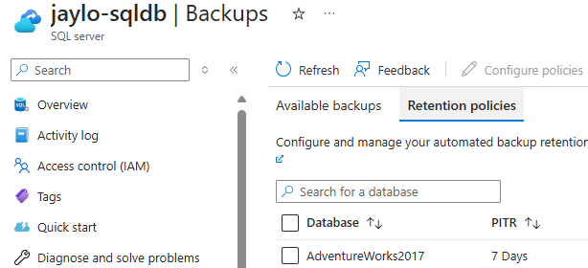

1. Click on **Retention policies**

1. Select the databases to change the retention policy for
2. Click **Configure policies**

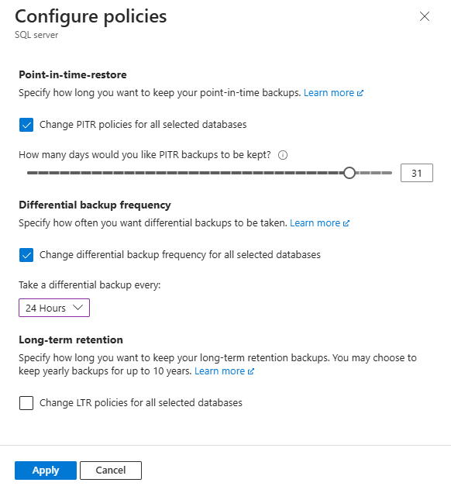

1. Check the options to change, and select the number of days, the hours, and/or any long term retention periods
2. Click **Apply**, then click **Yes** to confirm

1. Wait for the changes to be deployed

1. Once deployment is completed, go back to the database server, select backup, then select Retention policies to see the changes.

### Point-in-time/Long Term Retention Restores

1. Go to the SQL Database Server where the database exists that you want to restore

1. Select **Backups** under Data management

*FYI: You can also select* ***Restore*** *under the databases* ***Overview*** *page*

1. Under **Available backups** find the database to restore and click **Restore** under **Action**

1. For Select source you can just **Point-in-time** or **Long-term backup retention**

1. For Point-in-time, select the Restore point date and time



1. For Long-term backup retention, select the backup

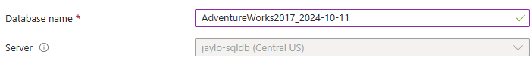

1. Choose a Database or leave as default
2. Change any other parameters as needed
3. Click **Review + create**

1. Validate settings, then click **Create**
2. You can rename the database in SSMS after the restore is completed

### Backup & Restore

1. Open SQL Server Management Studio

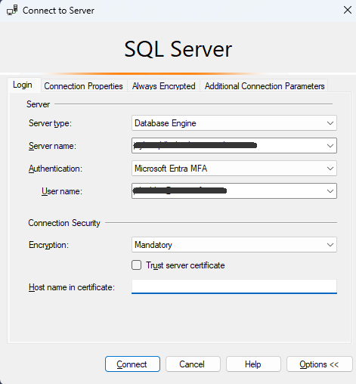

1. Log into your Azure SQL Server

1. Right-click on the database to backup, select **Tasks** and **Export Data-tier Application**

1. Click **Next >**

1. Click **Browse…** to select a location to store the bacpac file

1. Navigate to a location and enter a name for the bacpac file
2. Click **Next >**

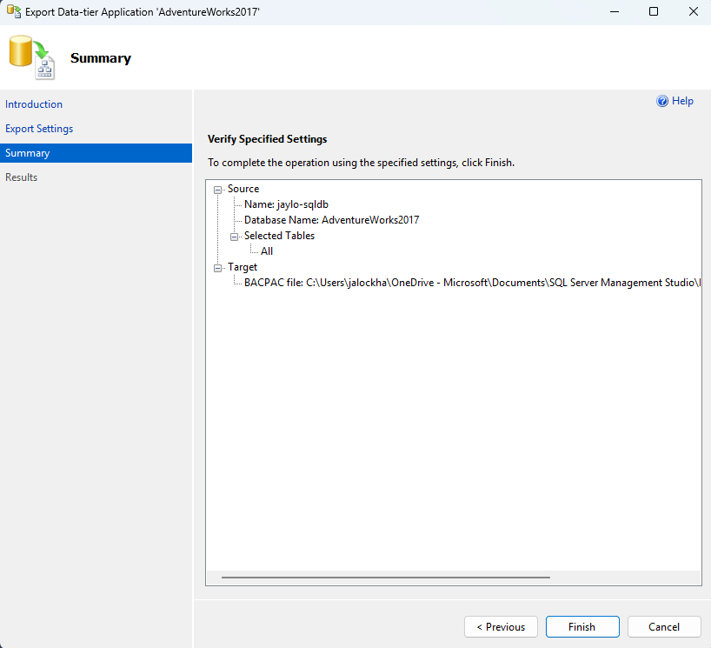

1. Click **Finish**

1. Wait for the export to complete
2. Close **Close** when complete
3. Log into the other Azure SQL Database Server

1. Right-click on Database and select Import Data-tier Application…

1. Click **Next >**

1. Click Browse… to select the previous created bacpac file

1. Select the file and flick **Open**

1. Click **Next >**

1. Change database name if need be, then click **Next >**

1. Click **Finish**

1. Wait for the import to complete
2. Close **Close** when complete

1. Right-click Databases and select Refresh

### HA/DR

1. **Failover Groups** – SQL DB Server Level & SQL MI

[Failover groups overview & best practices - Azure SQL Database | Microsoft Learn](https://learn.microsoft.com/en-us/azure/azure-sql/database/failover-group-sql-db?view=azuresql)

1. **Replicas** – SQL DB Database Level

[Active geo-replication - Azure SQL Database | Microsoft Learn](https://learn.microsoft.com/en-us/azure/azure-sql/database/active-geo-replication-overview?view=azuresql&tabs=tsql)

[Configure license-free standby replica - Azure SQL Database | Microsoft Learn](https://learn.microsoft.com/en-us/azure/azure-sql/database/standby-replica-how-to-configure?view=azuresql&tabs=azure-portal)

1. **Sync to Other databases** – SQL DB Database level

*FYI: SQL Data Sync will be retired on 30 September 2027.*

[What is SQL Data Sync for Azure? - Azure SQL Database | Microsoft Learn](https://learn.microsoft.com/en-us/azure/azure-sql/database/sql-data-sync-data-sql-server-sql-database?view=azuresql)

### Other Options

1. **Always On availability groups** tutorials:
   1. [Always On availability groups](https://learn.microsoft.com/en-us/sql/database-engine/availability-groups/windows/overview-of-always-on-availability-groups-sql-server)
   2. [Managed Instance link feature overview - Azure SQL Managed Instance](https://learn.microsoft.com/en-us/azure/azure-sql/managed-instance/managed-instance-link-feature-overview?view=azuresqldb-mi&preserve-view=true)
2. **Transactional replication** tutorial:
   1. [Transactional replication - SQL Server](https://learn.microsoft.com/en-us/sql/relational-databases/replication/transactional/transactional-replication)
3. **Linked server** tutorial:
   1. [Linked servers (Database Engine) - SQL Server](https://learn.microsoft.com/en-us/sql/relational-databases/linked-servers/linked-servers-database-engine)

### Links

[Change automated backup settings - Azure SQL Database | Microsoft Learn](https://learn.microsoft.com/en-us/azure/azure-sql/database/automated-backups-change-settings?view=azuresql&tabs=azure-portal)

[Restore an Azure SQL Database from one server to another server](https://www.mssqltips.com/sqlservertip/5189/restore-an-azure-sql-database-from-one-server-to-another-server/)

[What is SQL Data Sync for Azure? - Azure SQL Database | Microsoft Learn](https://learn.microsoft.com/en-us/azure/azure-sql/database/sql-data-sync-data-sql-server-sql-database?view=azuresql)

[SQL Data Sync retirement migration - Azure SQL Database | Microsoft Learn](https://learn.microsoft.com/en-us/azure/azure-sql/database/sql-data-sync-retirement-migration?view=azuresql)

## Blob Storage Backup & Restore

### Azure Backups

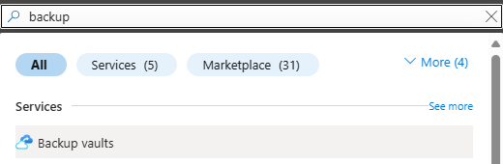

1. In the Azure Portal enter backup in the search bar and select **Backup vault**



1. Click **Create backup vault** in the middle of the screen or click **+ Create** at the top

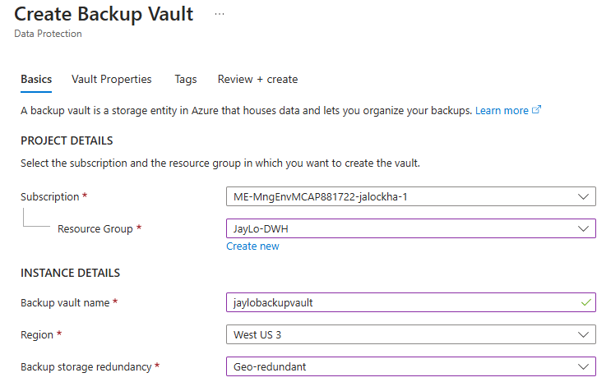

1. Select or create a Resource Group
2. Enter the Backup vault name
3. Select a Region
4. Select the Backup storage redundancy
5. Click **Next Vault Properties >**

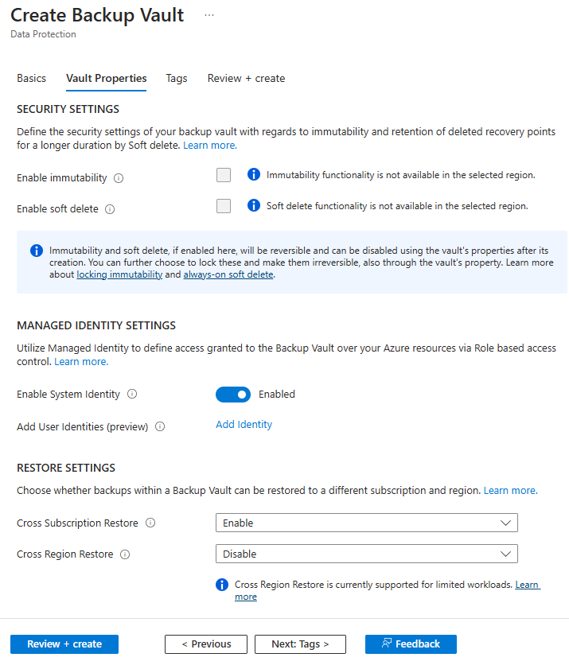

1. Change any properties that are appropriate
2. Click **Review + create**

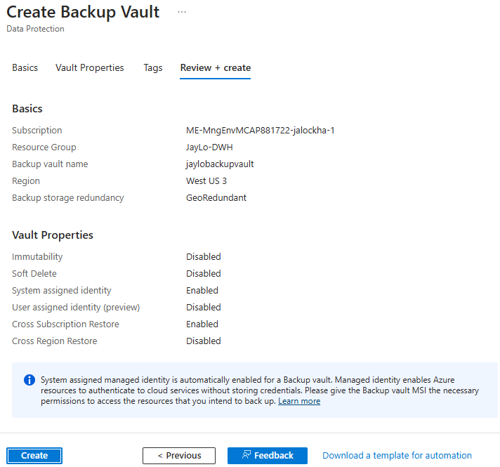

1. Review settings, then click **Create**

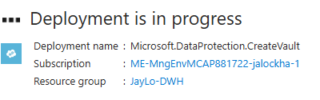

1. Wait for the deployment to complete, then click **Go to resource**

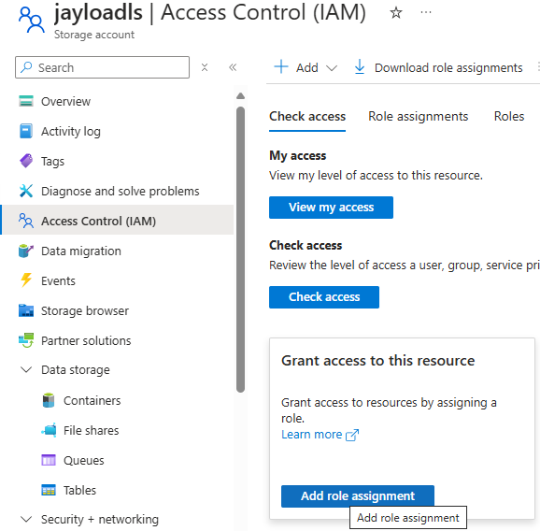

1. Go to the Storage Account that needs to be protected
2. Click on **Access control (IAM)** and select **Add role assignment**



1. Under **Role**, choose **Storage Account Backup Contributor**

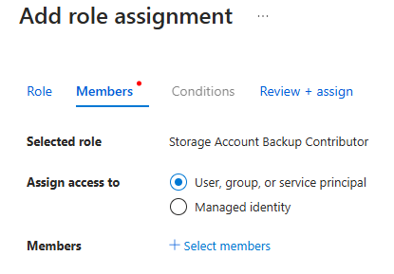

1. Click on **Members** and choose **User, group or service principal**, then click **+ Select members**

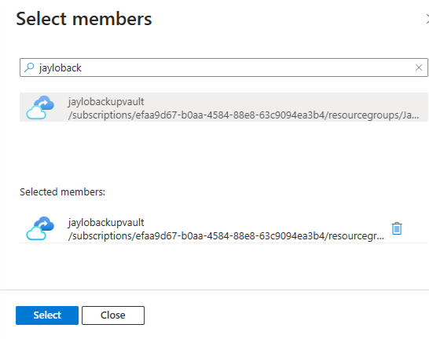

1. Search for the Backup vault you create earlier then select it from the search results
2. Click **Select**

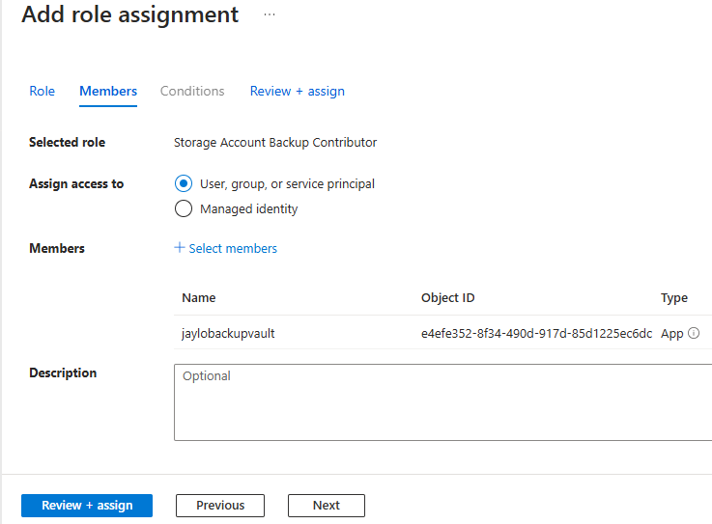

1. Click **Review + assign**

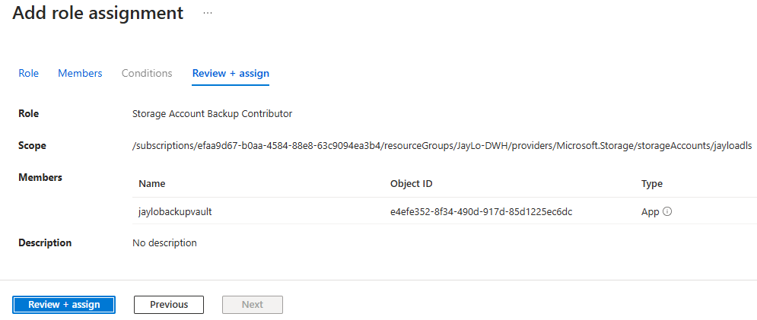

1. Click **Review + assign**

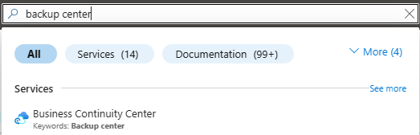

1. In the search bar type ’**backup center**‘ and select **Backup Continuity Center**

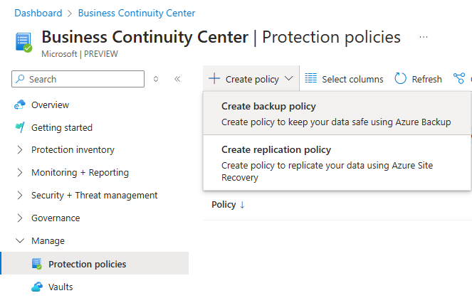

1. Under **Manage**, select **Protection policies**, then click the **+ Create policy** and select **Create backup policy**

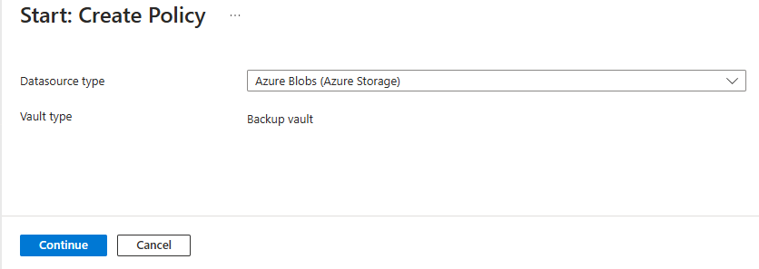

1. On the **Start: Create Policy** page, select **Azure Blobs (Azure Storage)** as the **Datasource type** then select **Continue**

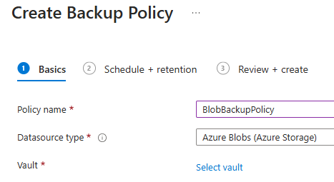

1. On the **Create Backup Policy** page enter a **Policy name**, and then from click **Select vault**

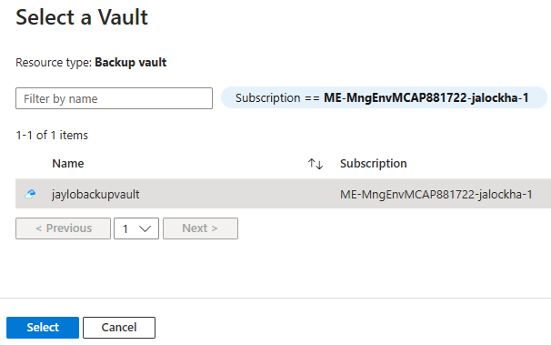

1. Choose the backup vault you created earlier, then click **Select**



1. Click **Next: Schedule + retention >**

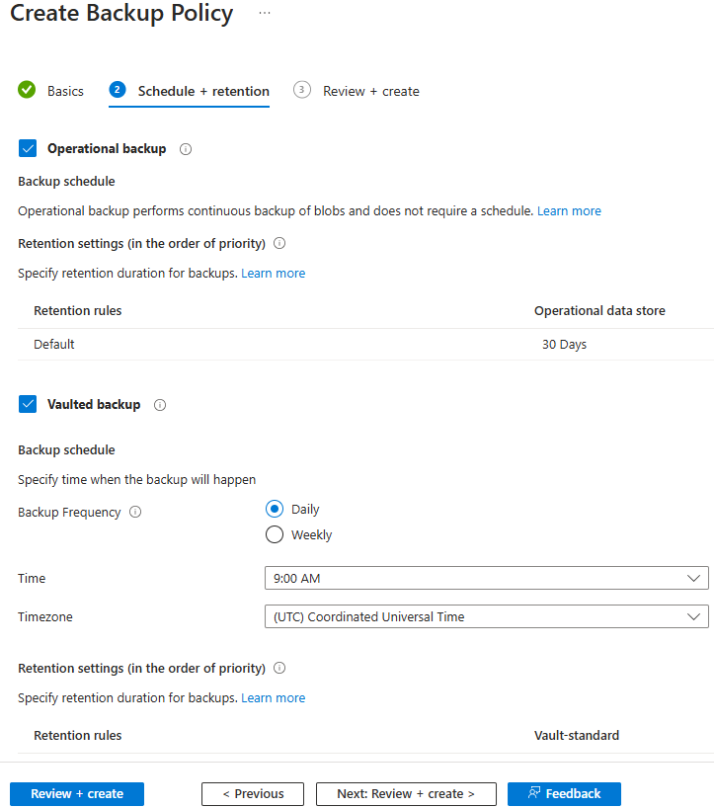

1. Set the appropriate schedule and retention, then click **Review + create**



1. Review the details of the selected vault in this tab, and then select **Create**

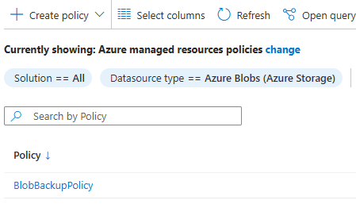

1. Change the **Datasource type** filter to Azure Blobs and you should see the policy you just created

*FYI: you can also go to the Backup Vault and under Overview click + Backup to create a backup*

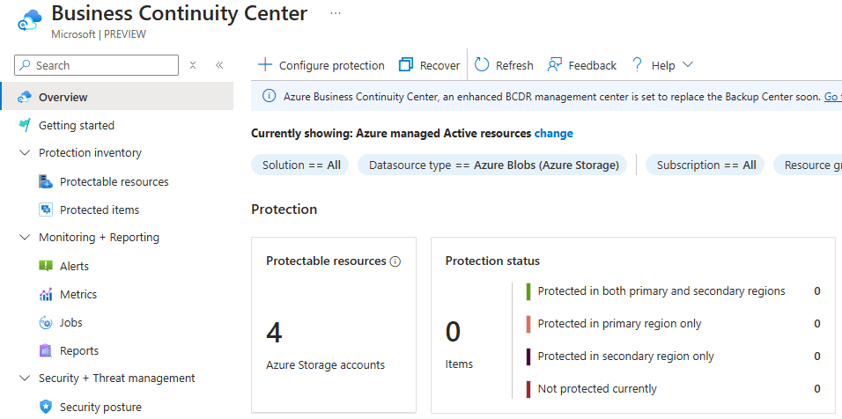

1. To Manage backups, go to the Backup Continuity Center and view the status of backups from the Overview menu

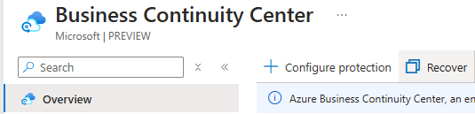

1. To Restore a Container, go to the Backup Vault and under **Overview** select **Restore**

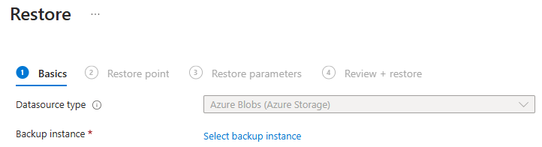

1. Click **Select backup instance**

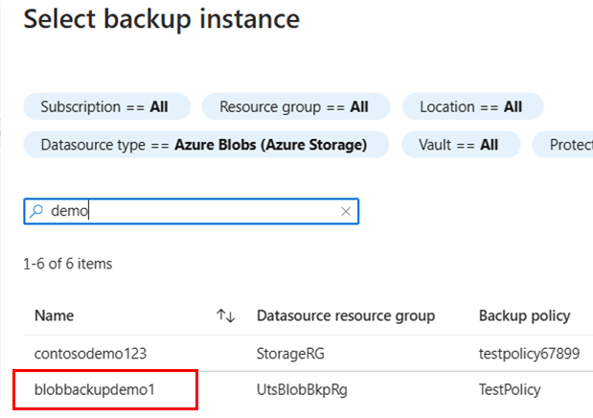

1. Enter the name of your backup to filter or just select the backup name

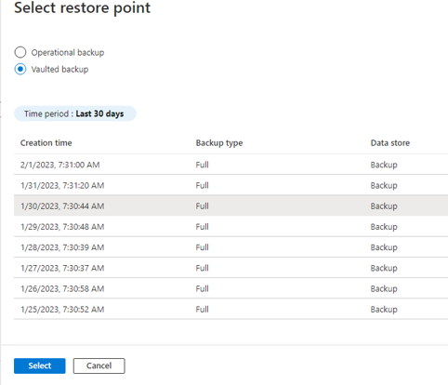

1. Select the restore point and click **Select**

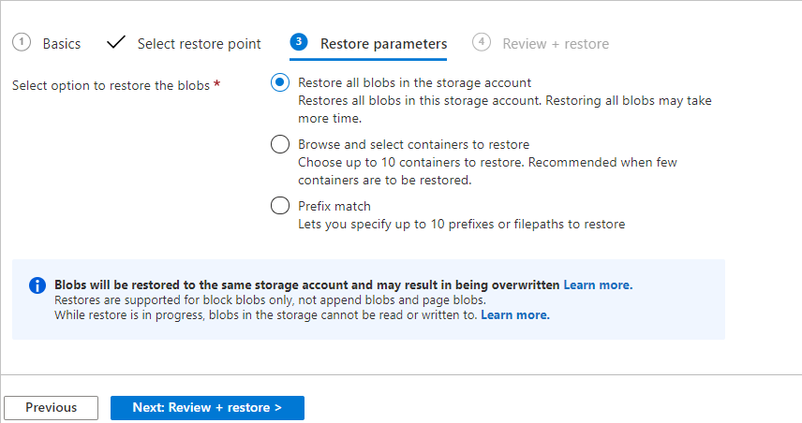

1. Select what to restore, then click **Next: Review + restore >**
2. Click **Restore**
3. Go to your storage account to see the restore containers

### AzCopy

* 1. Copy a **Blob**

azcopy copy 'https://<source-storage-account-name>.<blob or dfs>.core.windows.net/<container-name>/<blob-path>' 'https://<destination-storage-account-name>.<blob or dfs>.core.windows.net/<container-name>/<blob-path>'

* 1. Copy a Directory

azcopy copy 'https://<source-storage-account-name>.<blob or dfs>.core.windows.net/<container-name>/<directory-path>' 'https://<destination-storage-account-name>.<blob or dfs>.core.windows.net/<container-name>' --recursive

* 1. Copy a **Container**

azcopy copy 'https://<source-storage-account-name>.<blob or dfs>.core.windows.net/<container-name>' 'https://<destination-storage-account-name>.<blob or dfs>.core.windows.net/<container-name>' --recursive

* 1. Copy containers, directories, and blobs

azcopy copy 'https://<source-storage-account-name>.<blob or dfs>.core.windows.net/' 'https://<destination-storage-account-name>.<blob or dfs>.core.windows.net/' –recursive

### Azure Storage Explorer

*FYI: Azure Storage Explorer uses AzCopy to perform all of its data transfer operations. You can use Storage Explorer if you want to apply the performance advantages of AzCopy, but you prefer to use a graphical user interface rather than the command line to interact with your files.*

1. Download Azure Storage Explorer an Install

[Azure Storage Explorer – cloud storage management | Microsoft Azure](https://azure.microsoft.com/en-us/products/storage/storage-explorer/)

1. Open Azure Storage Explorer and click on the **Account Manager (person)** in the upper left corner
2. Click Sign in with Azure

1. Select the appropriate environment, then click Next



1. A browser window should open, select the appropriate login and click **Next**, then click **Sign in**
2. Approve MFA if necessary
3. Return to Azure Storage Explorer

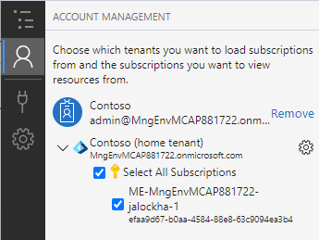

1. Select the Subscription(s) that you plan to explorer, then click on the Explorer on the top left-hand side

1. Open the Blob Container that you wish to copy from

1. Select the blob to copy, then click **Copy** at the top

1. Select the Container to copy to, then click **Paste**

### Data Factory Pipeline

*FYI: Pipelines can be used in Data Factory, Synapse Analytics or Microsoft Fabric. Below instructions are using Microsoft Fabric*

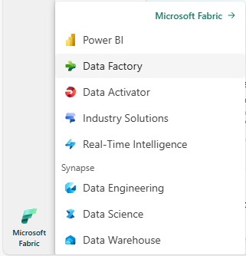

1. Log into Microsoft Fabric and in the lower left-hand corner select Data Factory

1. Select **Data pipeline** under Recommended items to create

1. Give your new pipeline a name

1. Select **Copy data assistant**

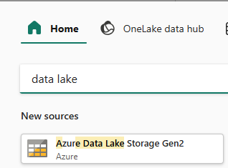

1. Type **data lake** in the search bar and select **Azure Data Lake Storage Gen2**

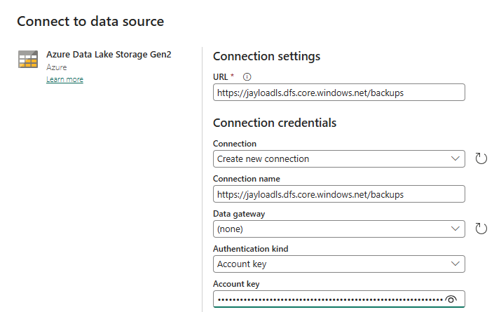

1. Enter the URL for your Data Lake Gen 2 container to copy from

*Found under* ***Properties*** *of the container*

1. Change the work ‘**blob’** in the URL to ‘**dfs’**
2. Leave Connection as **Create new connection**
3. Change the Connection name if needed
4. Leave Data gateway as **(none)**
5. Select **Account Key** as the **Authentication kind**
6. Copy and paste **key 1** found under the Storage Account **Access keys** setting
7. Click **Next**

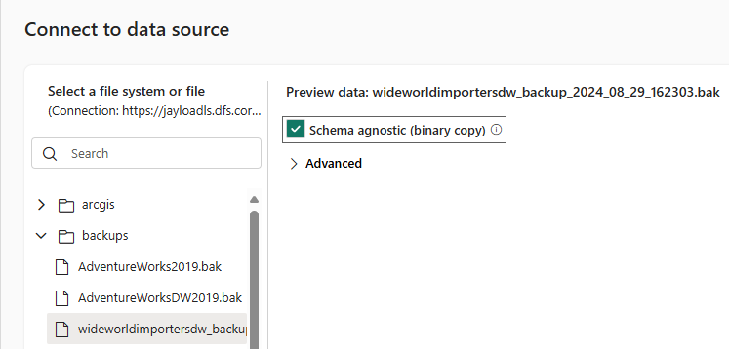

1. Select the blob to copy
2. If the file to back up is a file such as a **.bak** file, check **Schema agnostic (binary copy)**
3. If the file is not a **.bak** file, such as a json or csv, select the **File format**, **Column delimiter** and **Row delimiter**
4. Click **Next**



1. Type “data lake” in the search bar and select **Azure Data Lake Storage Gen2**

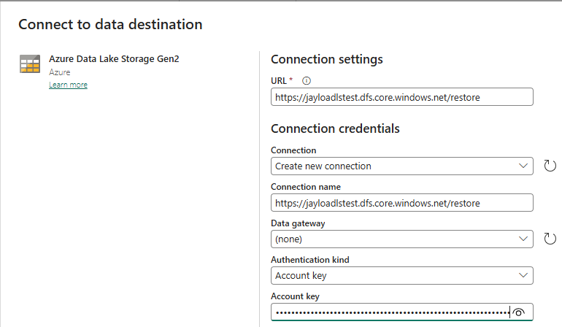

1. Enter the URL for your Data Lake Gen 2 container to copy to

*Found under* ***Properties*** *of the container*

1. Change the work ‘**blob’** in the URL to ‘**dfs’**
2. Leave Connection as **Create new connection**
3. Change the Connection name if needed
4. Leave Data gateway as **(none)**
5. Select **Account Key** as the **Authentication kind**
6. Copy and paste **key 1** found under the Storage Account **Access keys** setting
7. Click **Next**

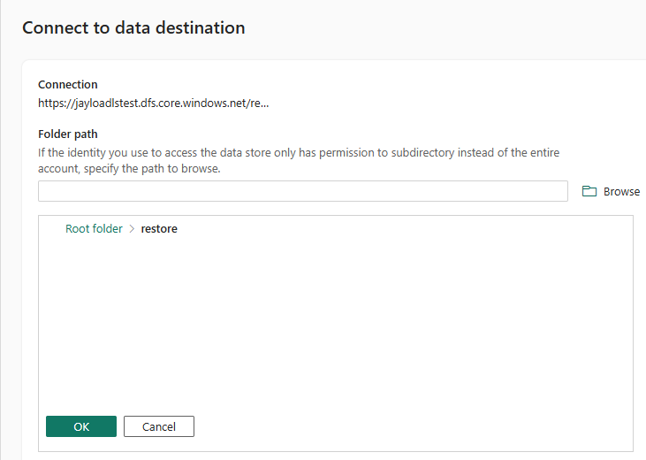

1. Click **Browse** and select the storage container to use
2. Click **OK**
3. Click **Next**

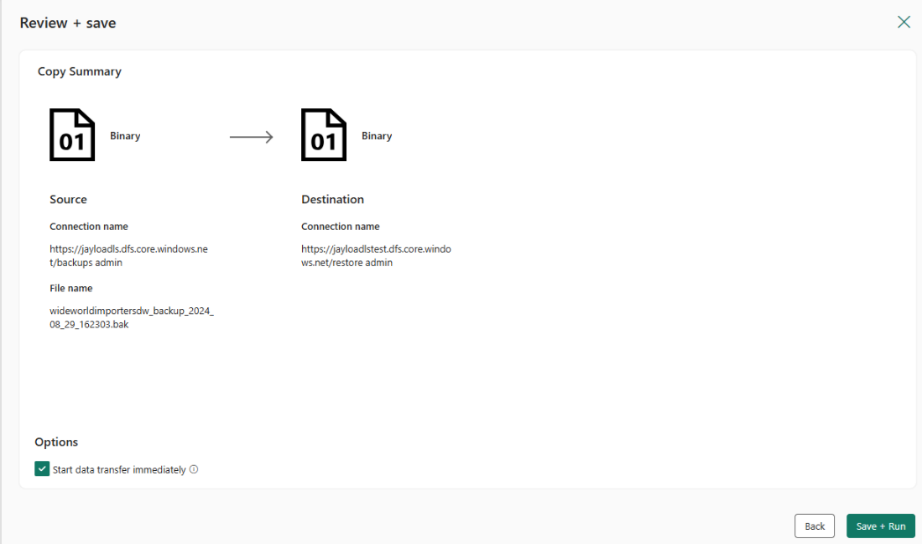

1. Click **Save + Run**

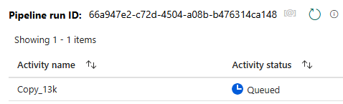

1. Pipeline will be Queued up to run

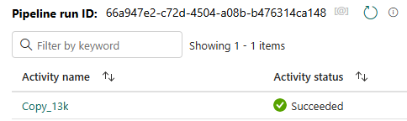

1. Wait for the pipeline to complete

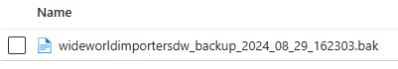

1. Go to the Storage Account Container in Azure to see the copied file

### Point-in-time Restore

*FYI: Point-in-time cannot be enable on a storage account where hierarchical namespace is enabled*

1. To enable **Point-in-time restores**, log into the Azure Portal
2. Navigate to your Storage Account

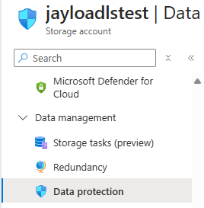

1. Under **Data management**, choose **Data Protection**

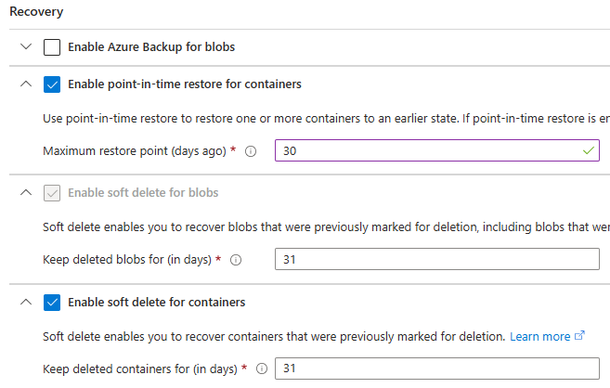

1. Check **Enable point-in-time restore for containers**

*FYI: When you select this option, soft delete for blobs, versioning, and change feed are also enabled*

1. Set the **Maximum restore point for (in days)**

*FYI: This number must be at least one day less than the retention period specified for blob soft delete*

1. Click **Save**
2. To Restore all containers are a selected container, under the Storage Account, click on **Containers**

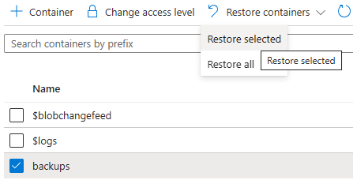

1. Select the Container(s) to restore
2. Click **Restore containers** and select either **Restore selected** or **Restore all**

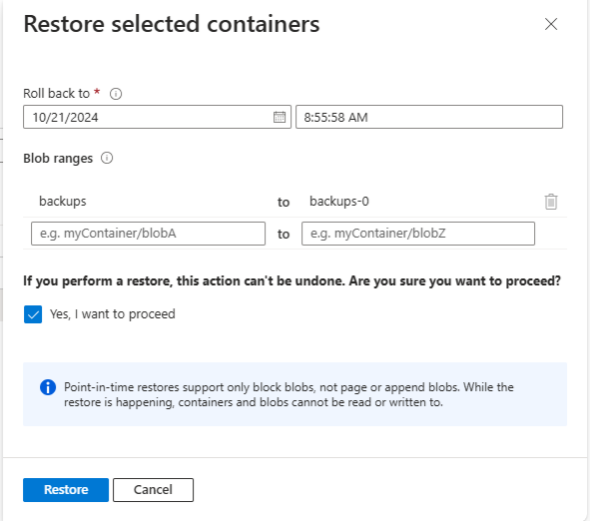

1. Select the appropriate restore point, check **Yes, I want to proceed**, then click **Restore**

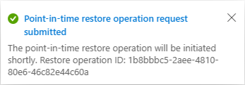

1. Restore complete

### Links

[Restore Azure Blobs - Azure Backup | Microsoft Learn](https://learn.microsoft.com/en-us/azure/backup/blob-restore?tabs=operational-backup)

[Copy blobs between Azure storage accounts with AzCopy v10 | Microsoft Learn](https://learn.microsoft.com/en-us/azure/storage/common/storage-use-azcopy-blobs-copy)

[Copy and transform data in Azure Data Lake Storage Gen2 - Azure Data Factory & Azure Synapse | Microsoft Learn](https://learn.microsoft.com/en-us/azure/data-factory/connector-azure-data-lake-storage?toc=%2Fazure%2Fstorage%2Fblobs%2Ftoc.json&bc=%2Fazure%2Fstorage%2Fblobs%2Fbreadcrumb%2Ftoc.json&tabs=data-factory)

[Perform a point-in-time restore on block blob data - Azure Storage | Microsoft Learn](https://learn.microsoft.com/en-us/azure/storage/blobs/point-in-time-restore-manage?tabs=portal)

## Service Bus Backup & Restore

### Geo-Disaster Recovery

*The Service Bus Geo-Disaster Recovery feature is one of the options to*[*insulate Azure Service Bus applications against outages and disasters*](https://learn.microsoft.com/en-us/azure/service-bus-messaging/service-bus-outages-disasters)*, and primarily aims at helping to preserve the integrity of the composite application configuration.*

1. Create the primary Azure Service Bus as a premium-tier namespace in a specific region, then navigate to the primary namespace

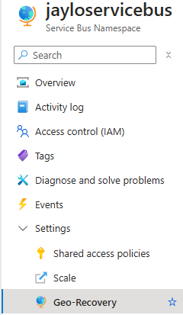

1. Under **Settings** select **Geo-Recovery**

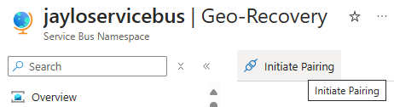

1. Select **Initiate pairing** on the toolbar.

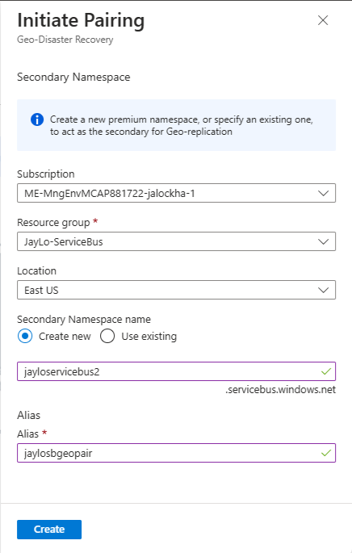

1. Select the **Subscription**, **Resource Group** and **Location** for the secondary Namespace
2. Enter a name for the Secondary Namespace
3. Enter an Alias for the Geo-Disaster Recovery pairing
4. Click **Create**

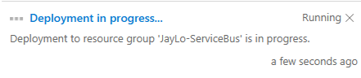

1. Wait for the deployment to complete

*FYI: This may take several minutes to complete*

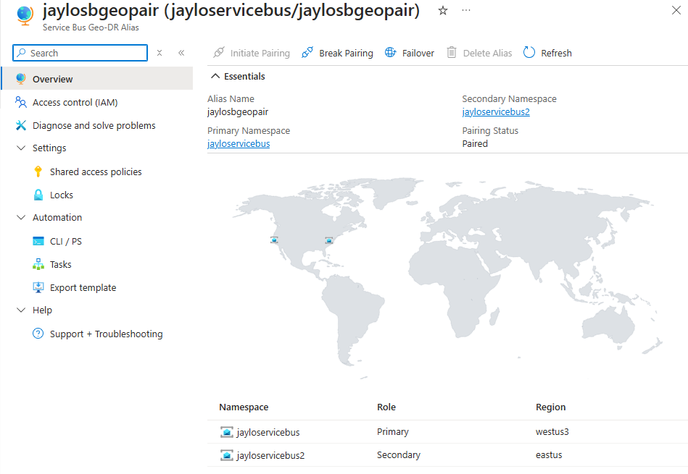

1. Now you can failover to the secondary region by clicking the Failover button

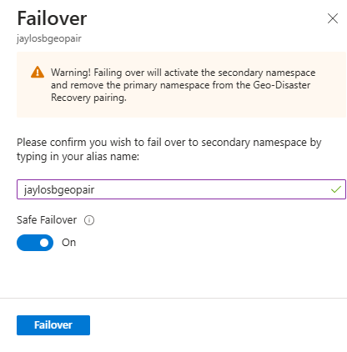

1. Enter the **Alias Name**, turn on **Safe Failover**, then click **Failover**

### Geo-Replication

*The Service Bus Geo-Replication feature is one of the options to insulate Azure Service Bus applications against outages and disasters, providing replication of both metadata*

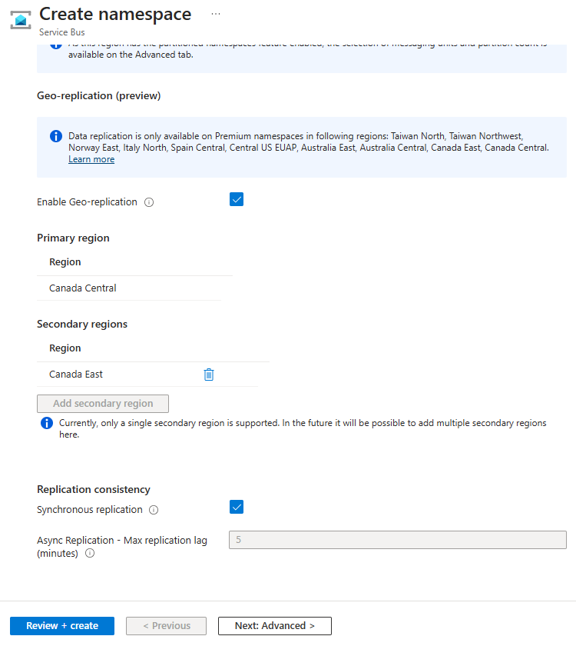

1. Check **Enable Geo-replication** under the **Geo-replication (preview)** section
2. Click on the **Add secondary region** button, and choose a secondary region
3. Either check **Synchronous replication** or specify a value for the **Async Replication - Max Replication lag** value in seconds
4. Click **Review + create**

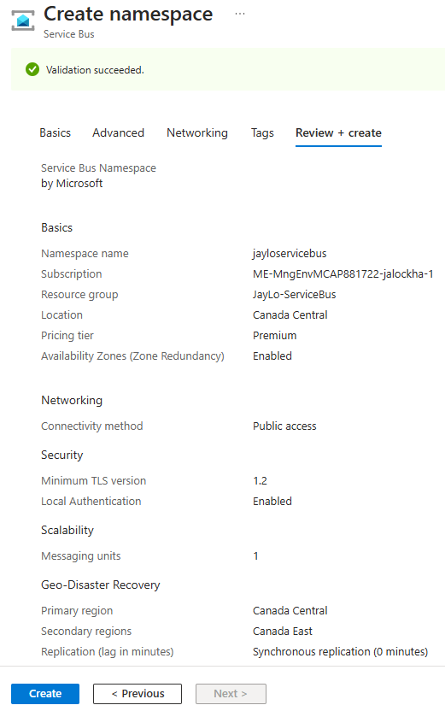

1. Validate the information then click **Create**

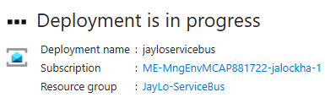

1. Wait for the deployment to complete



1. Click **Go to resource**
2. Under **Settings** click on **Geo-replication (preview)**

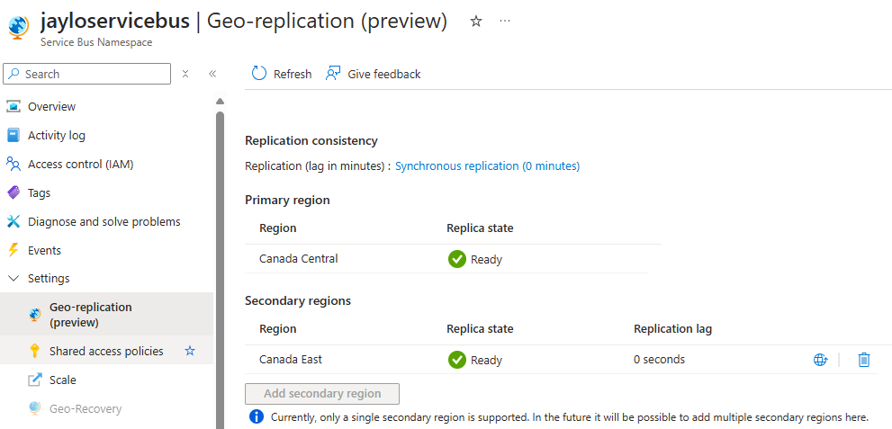

1. View the Geo-replication

### Links

[Azure Service Bus Geo-Disaster Recovery - Azure Service Bus | Microsoft Learn](https://learn.microsoft.com/en-us/azure/service-bus-messaging/service-bus-geo-dr)

[Azure Service Bus Geo-Replication - Azure Service Bus | Microsoft Learn](https://learn.microsoft.com/en-us/azure/service-bus-messaging/service-bus-geo-replication)

[Insulate Azure Service Bus applications against outages and disasters - Azure Service Bus | Microsoft Learn](https://learn.microsoft.com/en-us/azure/service-bus-messaging/service-bus-outages-disasters)

[Best practices for improving performance using Azure Service Bus - Azure Service Bus | Microsoft Learn](https://learn.microsoft.com/en-us/azure/service-bus-messaging/service-bus-performance-improvements?tabs=net-standard-sdk-2)

## Automation

### Azure Automation

[Manage schedules in Azure Automation | Microsoft Learn](https://learn.microsoft.com/en-us/azure/automation/shared-resources/schedules)

### PowerShell

[Choose the right Azure command-line tool - Azure CLI | Microsoft Learn](https://learn.microsoft.com/en-us/cli/azure/choose-the-right-azure-command-line-tool)

[What is the Azure CLI? | Microsoft Learn](https://learn.microsoft.com/en-us/cli/azure/what-is-azure-cli)

### Azure Functions, Azure Logic Apps, PowerApps & Power Automate

[Using Azure Functions in PowerApps - Microsoft Power Platform Blog](https://www.microsoft.com/en-us/power-platform/blog/power-apps/using-azure-functions-in-powerapps/?msockid=2786db6710dc6576081cce4711f564a9)

[About schedules for recurring triggers in workflows - Azure Logic Apps | Microsoft Learn](https://learn.microsoft.com/en-us/azure/logic-apps/concepts-schedule-automated-recurring-tasks-workflows)

[Create and use dataflows in Power Apps - Power Apps | Microsoft Learn](https://learn.microsoft.com/en-us/power-apps/maker/data-platform/create-and-use-dataflows)

[Run flows on a schedule in Power Automate - Power Automate | Microsoft Learn](https://learn.microsoft.com/en-us/power-automate/run-scheduled-tasks?tabs=classic-designer)